|  |  |
| --- | --- |
| COLOUR_LOGO Aug 2010 | **ATAR Year 12Physics** **2016**  ***TEST 1 Charged Particles in E Fields 5.0%***  **NAME: ………………………………………………….**  Data: See Data Sheet  Approx. marks shown.  ***( 64 marks)*** |

When calculating numerical answers, show your working or reasoning clearly. Give final answers to **three** significant figures and include appropriate units where applicable.

Physics C Electricity and Magnetism Internet Worksheet pg5 Q1

1. Multiple Choice [4]

(a) When a hard rubber rod is given a negative charge by rubbing it with wool:

1. positive charges are transferred from rod to wool
2. negative charges are transferred from wool to rod
3. positive charges are transferred from wool to rod
4. negative charges are transferred from rod to wool
5. negative charges are created and stored on the rod

Physics C Electricity and Magnetism Internet Worksheet pg5 Q2

(b) A negatively charged insulating rod is brought close to an object that is suspended by a string.

If the object is repelled from the rod we can conclude:

1. The object is positively charged
2. The object is negatively charged
3. The object is an insulator
4. The object is a conductor

Physics C Electricity and Magnetism Internet Worksheet pg6 Q4

(c) Two charges are repelling each other with a force magnitude *F*. If each charge doubled and the distance between the charges becomes four times the original distance, determine the new magnitude of the force. Show your working in the space provided.

A. ½ *F*

Working:

B. 4 *F*

C. 2 *F*

D. 16 *F*

E. ¼ *F*

2. (a) Consider the following diagram of 3 point charges.

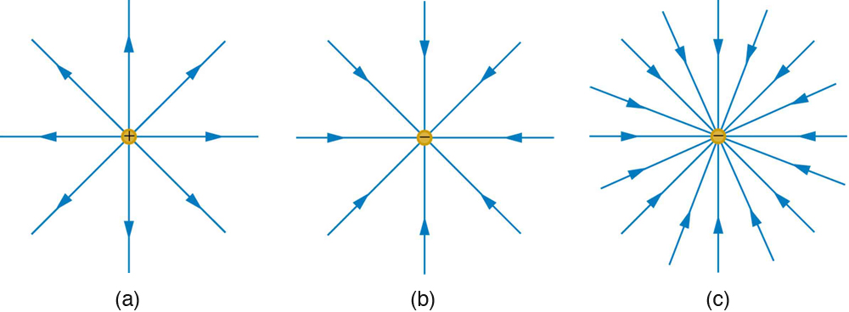

1. Show the polarity of the charges on the diagram. [1]
2. What can be concluded about the magnitude of the 3 charges? Explain. [1]

...........................................................................................................................................

...........................................................................................................................................

...........................................................................................................................................

(b) Draw the electric field distribution around the following arrangement of 3 point charges [3]

|  |  |
| --- | --- |
| Working diagram | Resultant diagram |
| **+**  **–**  **–** | **+**  **–**  **–** |

(c) Explain the characteristics of the picture of the charge distribution shown below. [3]



...........................................................................................................................................

...........................................................................................................................................

...........................................................................................................................................

...........................................................................................................................................

...........................................................................................................................................

...........................................................................................................................................

Physics C Electricity and Magnetism Internet Worksheet pg3 Q6

3. Evaluate the sketch below, assuming that the dot in the centre of each line is the same charge for each arrangement. The arrangements do not interact with each other and the charges are evenly spaced.

Space for working

|  |  |
| --- | --- |
| A  B  C | _Pic1 |

1. Determine which central charge has the greatest net force acting on it. [2]

...........................................................................................................................................

1. Determine the direction of the net force on the central charge from (a) if it is positive. [1]

...........................................................................................................................................

Glencoe Physics pg 548 Fig 1 mod

4. A student rubs a balloon on their jumper and the holds it near the fur of their cat, as shown below.



1. Explain why the balloon can cause the cat's hair to stand up. [A diagram may be useful.] [4]

...........................................................................................................................................

...........................................................................................................................................

...........................................................................................................................................

...........................................................................................................................................

...........................................................................................................................................

...........................................................................................................................................

...........................................................................................................................................

1. Why would the cat's hair be more likely to stand up on a dry day than on a wet day?

[2]

...........................................................................................................................................

...........................................................................................................................................

...........................................................................................................................................

...........................................................................................................................................

...........................................................................................................................................

Glencoe Physics pg 564 Q37 mod

|  |  |
| --- | --- |
| 5. A strong lightning bolt strikes a tree and transfers about 25 C to Earth.  (a) How many electrons are transferred? [2]  …………………………………………………  …………………………………………………  …………………………………………………  …………………………………………………  ………………………………………………… | http://www.johnlund.com/ArticleImages/LightningStrike.jpg |

(b) If the transfer through the tree takes 4.0 ms, what current flows though the tree? [2]

...........................................................................................................................................

...........................................................................................................................................

...........................................................................................................................................

Glencoe Physics pg 560 Q10 mod

6. (a) A body having a negative charge of –6.0 μC exerts an attractive force of 65 N on a second charged body that is 5.0 cm away. What is the magnitude and polarity of the second charge? [3]

...........................................................................................................................................

...........................................................................................................................................

...........................................................................................................................................

...........................................................................................................................................

...........................................................................................................................................

...........................................................................................................................................

...........................................................................................................................................

(b) The charged bodies in (a) then make contact and are returned to the same distance apart. Determine the new force between them. [3]

...........................................................................................................................................

...........................................................................................................................................

...........................................................................................................................................

...........................................................................................................................................

...........................................................................................................................................

...........................................................................................................................................

...........................................................................................................................................

Physics C Electricity and Magnetism Internet Worksheet pg6 Q5

7. Point R is 0.40 m from a –2 x 10–5 C charge. Find the electric field intensity at point R. [3]

...........................................................................................................................................

...........................................................................................................................................

...........................................................................................................................................

...........................................................................................................................................

...........................................................................................................................................

Glencoe Physics pg 581 Q29

8. The electric field in a particle accelerator has a magnitude of 4.50 x 105 NC–1. How much work is done to move a proton 25 cm through that field? [3]

...........................................................................................................................................

...........................................................................................................................................

...........................................................................................................................................

...........................................................................................................................................

...........................................................................................................................................

...........................................................................................................................................

...........................................................................................................................................

...........................................................................................................................................

...........................................................................................................................................

Glencoe Physics pg 580 Q24

|  |  |
| --- | --- |
| 9. (a) When you apply a potential difference of 125 V between two parallel plates, the field between them is 4.25 x 103 Vm–1. How far apart are the plates? [2]  ……………………………………………………………  ……………………………………………………………  ……………………………………………………………  ……………………………………………………………  …………………………………………………………… | _Pic1 |

(b) A proton is released from the positive plate. At what speed will it be travelling as it reached the negative plate? Show your working clearly. [3]

...........................................................................................................................................

...........................................................................................................................................

...........................................................................................................................................

...........................................................................................................................................

...........................................................................................................................................

Glencoe Physics pg 595 Q6 mod

10. In an oil drop experiment, a drop with a mass of 2.22 x 10–15 kg was suspended motionless when the potential difference between the plates that were 63 mm apart was 0.78 kV.

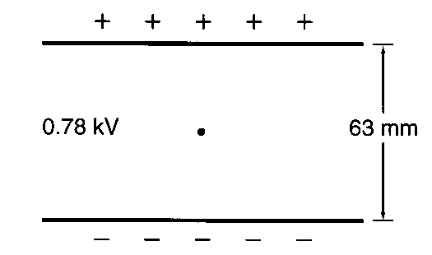

1. On the diagram above draw the electric field between the parallel plates. [2]
2. (i) What was the charge of the drop? Show your working clearly. [4]

…........................................................................................................................................

…........................................................................................................................................

…........................................................................................................................................

…........................................................................................................................................

…........................................................................................................................................

…........................................................................................................................................

(ii) Does the oil drop have a deficiency or an excess of electrons? Explain briefly

[2]

…........................................................................................................................................

…........................................................................................................................................

…........................................................................................................................................

1. If the voltage of the bottom plate is – 100 V what is the potential of the top plate?

[1]

…........................................................................................................................................

Glencoe Physics pg 594 Q103

11. In an ink-jet printer, drops of ink are given a certain amount of charge before they move between two large, parallel plates. The plates deflect the charged ink particles as shown in Figure below. The plates have an electric field of E = 1.20 x 106 N/C between them and are 1.5 cm long. Drops with a mass m = 0.100 ng and a charge q = 1.00 x 10–16 C are moving horizontally at a speed, v = 15.0 m/s, parallel to the plates.

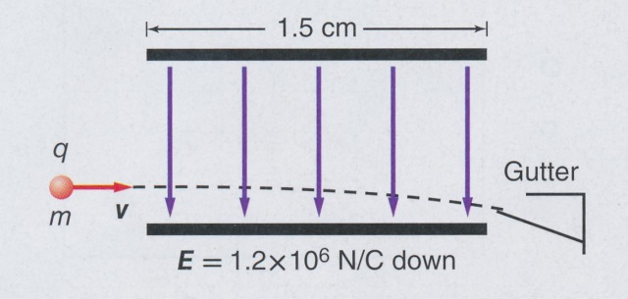

1. What is the vertical force on the drops? [2]

…........................................................................................................................................

…........................................................................................................................................

…........................................................................................................................................

1. What is their vertical acceleration? [2]

…........................................................................................................................................

…........................................................................................................................................

…........................................................................................................................................

1. How long are they between the plates? [2]

…........................................................................................................................................

…........................................................................................................................................

…........................................................................................................................................

1. How far are they displaced? [2]

…........................................................................................................................................

…........................................................................................................................................

…........................................................................................................................................

12. Two charges of 15 pC and 9.0 pC are separated by a distance of 20 mm. How far from the smaller charge will the electric field intensity be zero? Show your working clearly. [5]

...........................................................................................................................................

...........................................................................................................................................

...........................................................................................................................................

...........................................................................................................................................

...........................................................................................................................................

...........................................................................................................................................

...........................................................................................................................................

...........................................................................................................................................

...........................................................................................................................................

...........................................................................................................................................

...........................................................................................................................................

. ...........................................................................................................................................

...........................................................................................................................................

...........................................................................................................................................

...........................................................................................................................................

...........................................................................................................................................

...........................................................................................................................................

............................................................................................................................................

............................................................................................................................................